USER GUIDE

CULINARY CULTURE IN CANBERRA

<https://culinaryculture.tk/>

1. Insert URL <https://culinaryculture.tk/> in Web browser.

The below snapshot is what will be displayed. This is “What’s On” page, which captures current news and articles related to health.

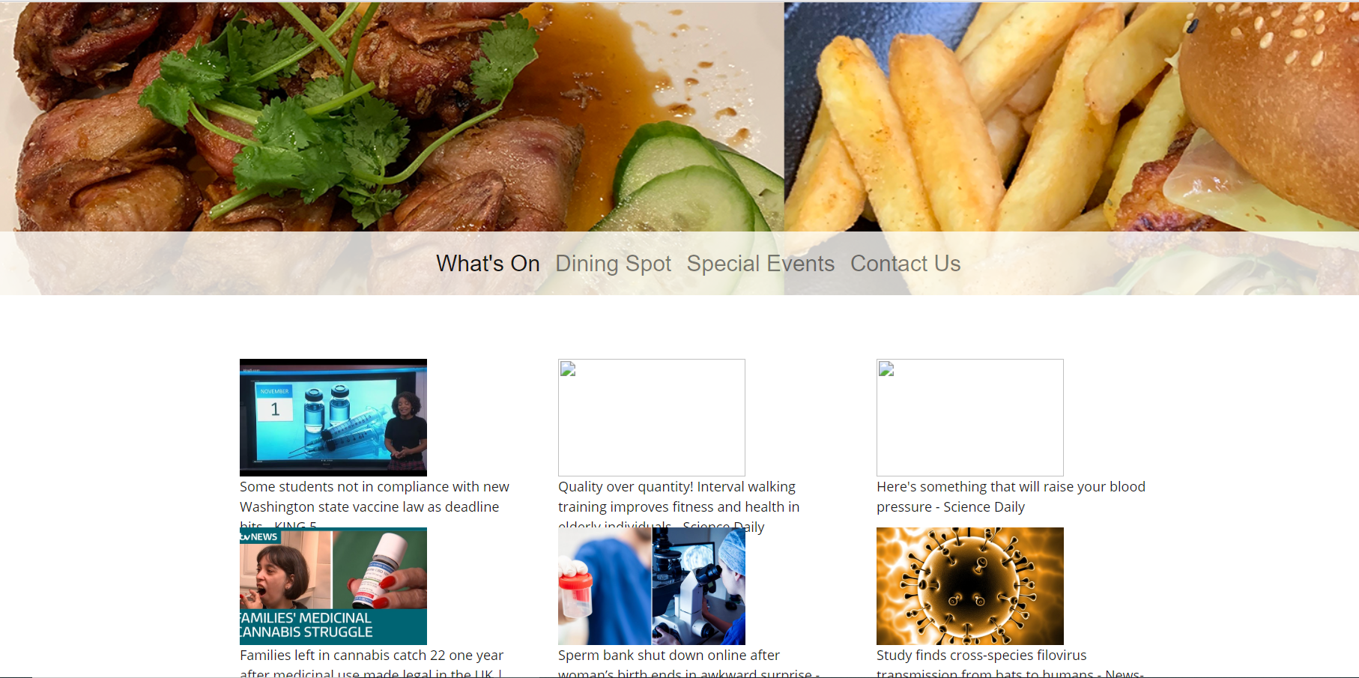

1. “Dinning spot” page will help users search relevant restaurants matching with the selected locations, radius and cuisine.

* 7 locations to choose: Places Near Me, Canberra Centre, Dickson, Belconnen, Dickson, Woden, Tuggeranong.
* 4 radiuses to choose: 1000m, 2000m, 3000m, 4000m.
* 6 cuisines to choose: Korean, Vietnamese, Italian, Spanish, Australian, Mexican.

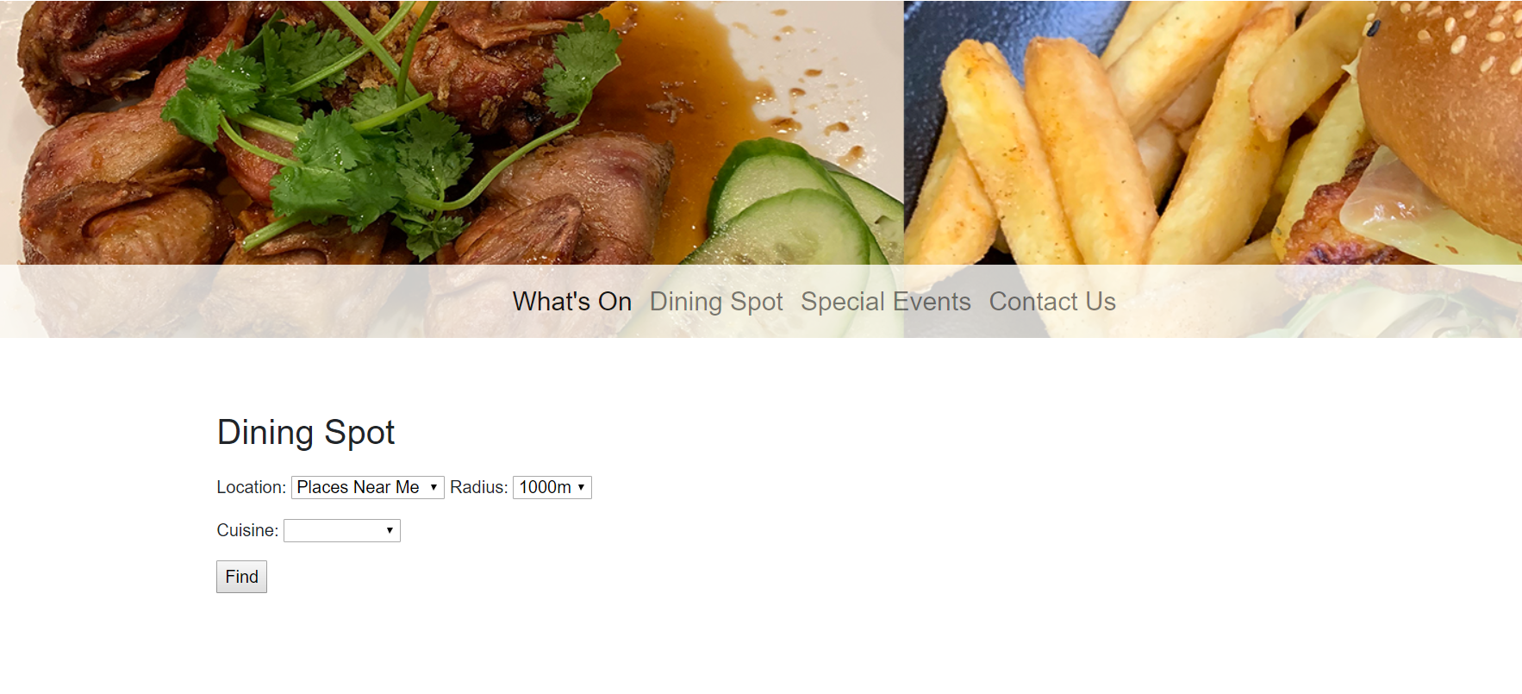

Click on “Find” to get the results.

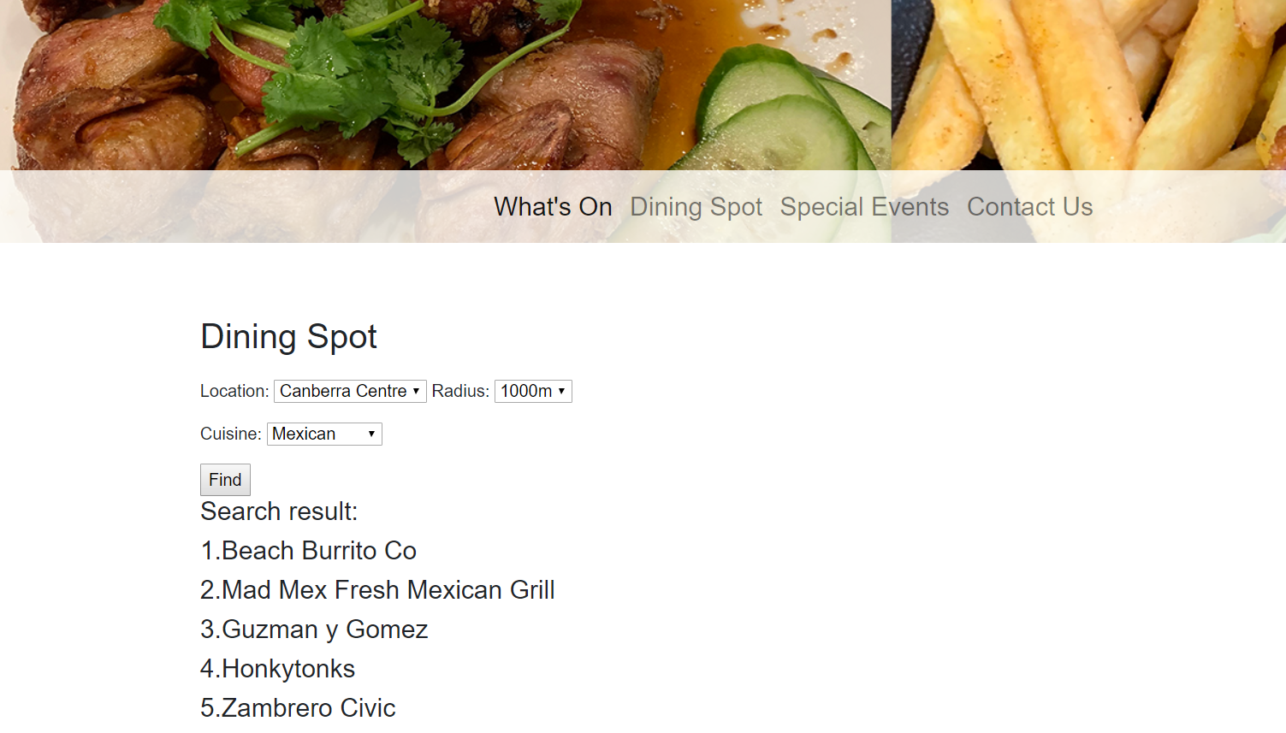

Click on prefer restaurant to get the map.

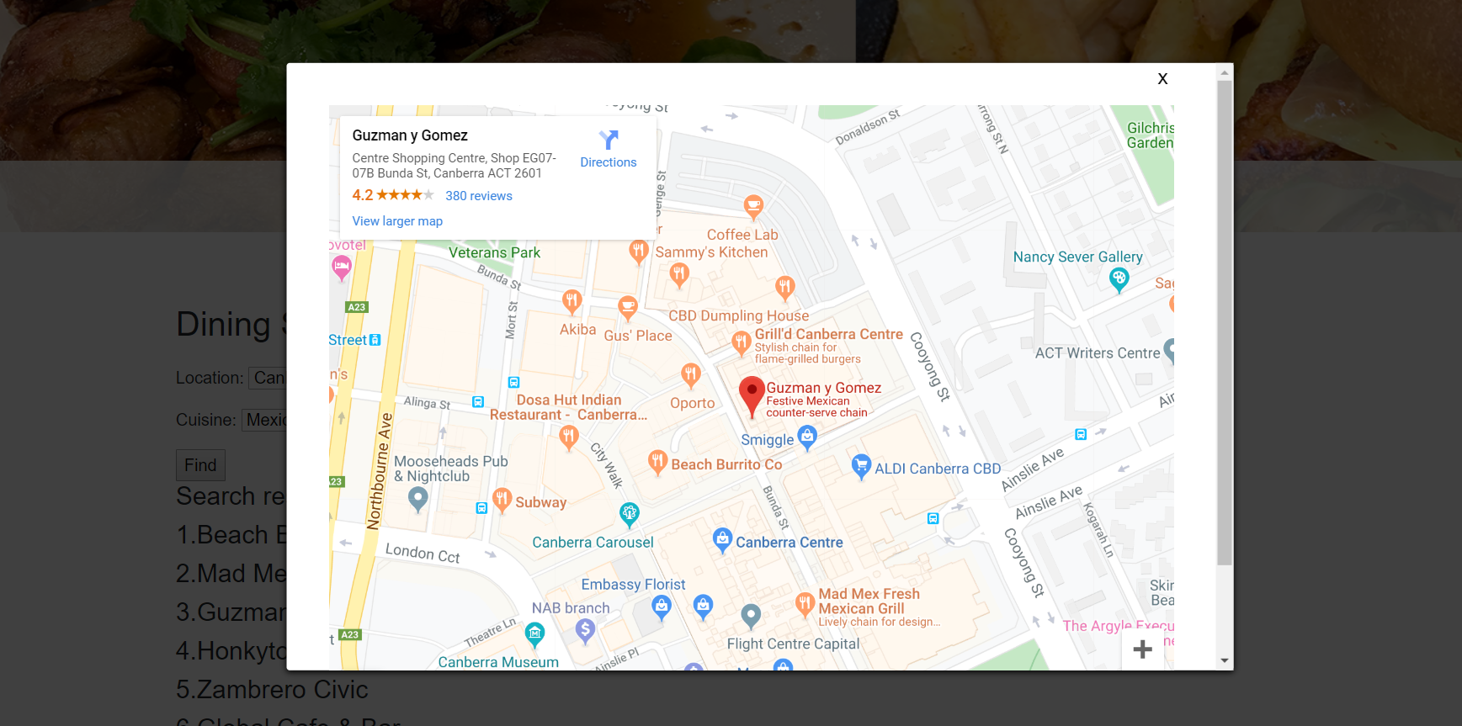

Click to close



1. “Special Events” page will display upcoming festivals. For example, Multicultural Festival, Night Noodle market Festival etc.

The main feature of this page is 3D photos of food which were taken for some selected cuisines. Users will experience themselves by rotating photos from right to left or vice versa.

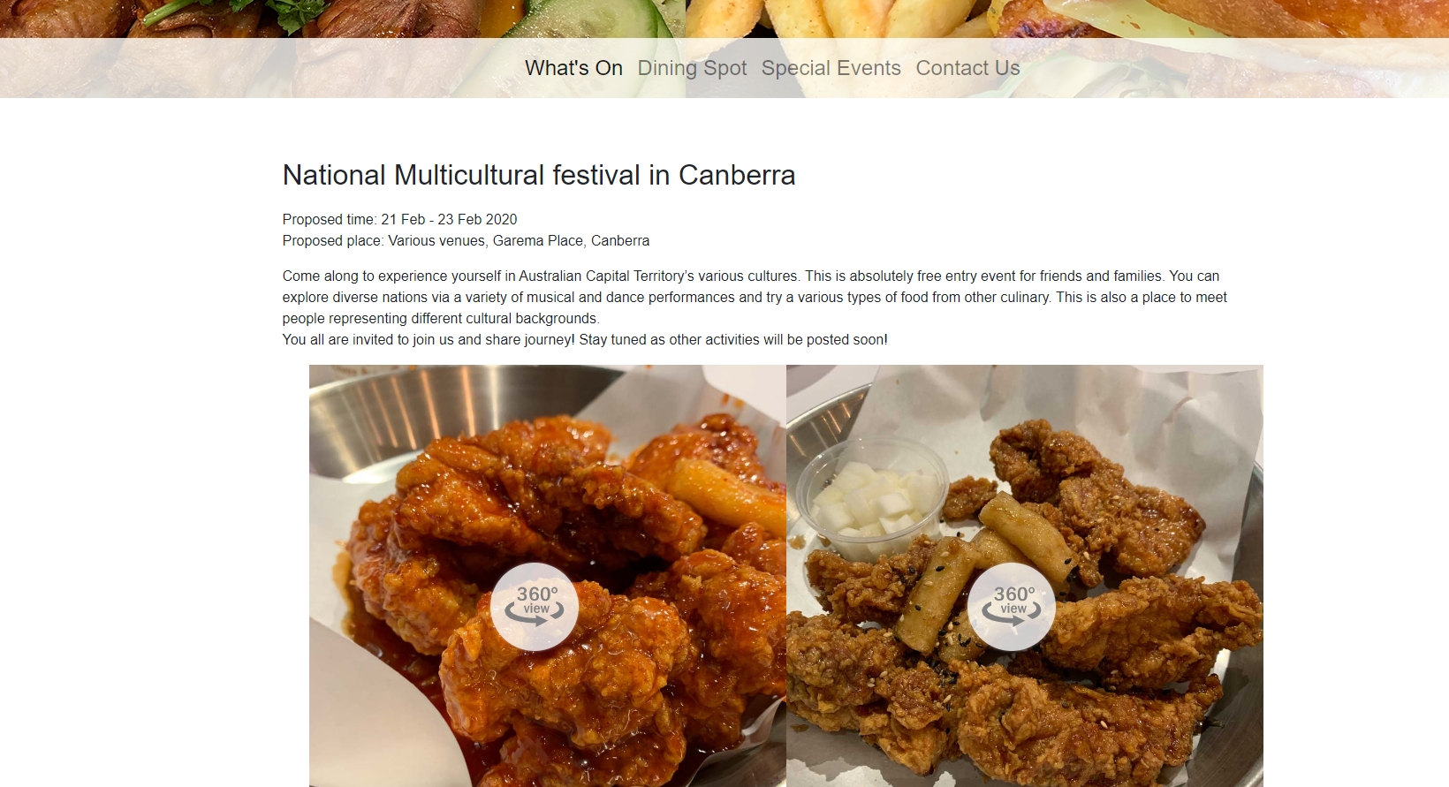

1. “Contact us” page is a contact form, which users need to fill in name, email address and enquiry messages before clicking “Submit” button.

The form details will be sent to admins and they will reply as soon as they can.

